# **Learn Hub**

**1.** INTRODUCTION

**1.1 Project Overview**

Learn Hub is an online learning management system (LMS) developed using the MERN (MongoDB, Express.js, React.js, Node.js) stack. This platform is designed to provide a comprehensive digital learning environment for both students and educators. Learn Hub enables teachers to create, manage, and deliver courses online, while students can enroll in and complete courses, track progress, and receive certificates upon successful completion. The system includes user role management, including Admin, Teacher, and Student functionalities, and supports course creation, video content integration, section-wise progress tracking, and course assignment capabilities. The goal of Learn Hub is to provide an intuitive, scalable, and accessible platform for digital education that promotes engagement and learning outcomes.

**1.2 Purpose**

The purpose of this document is to provide a detailed description of the Learn Hub platform, including its objectives, features, and technical specifications. This documentation aims to serve as a comprehensive guide for developers, testers, project evaluators, and stakeholders. It outlines the motivation behind the project, the core problems it seeks to solve, and the ways in which it addresses the challenges of modern digital education. The document also describes the system architecture, functional and non-functional requirements, user interface design, and deployment details to ensure a clear understanding of the project scope and execution strategy.

# 2. IDEATION PHASE

**2.1 Problem Statement**

**Customer Problem Statement Template:**

A customer problem statement describes the issues your target users face and sets the stage for designing impactful solutions. We have defined the problems from both students' and teachers' perspectives.

|  |  |  |  |  |  |
| --- | --- | --- | --- | --- | --- |
| **Problem Statement (PS)** | **I am (Customer)** | **I’m trying to** | **But** | **Because** | **Which makes me feel** |
| **PS-1** | A college student in a remote area | Learn programming and access quality course materials online | I can’t find structured courses and reliable mentorship | Most platforms are either paid or don't allow interaction with educators | Frustrated, demotivated, and left out in the digital education space |
| **PS-2** | A teacher who wants to share knowledge digitally | Create and manage courses, and assign them to students efficiently | I don’t have a centralized tool for course creation, assigning, and tracking progress | Current systems are either too complex or not tailored for academic use | Disconnected from students and limited in delivering knowledge effectively |

**2.2 Empathy Map Canvas**

**Empathy Map Canvas**

An empathy map is a simple, easy-to-digest visual that captures knowledge about a user’s behaviours and attitudes. It is a useful tool to help teams better understand their users.

Creating an effective solution requires understanding the true problem and the person who is experiencing it. The exercise of creating the map helps participants consider things from the user’s perspective along with their goals and challenges.

**User: Student / Teacher / Admin**

**Says**

* "I want a platform where I can easily access learning content."
* "I need a simple way to manage my courses and students."
* "Security and simplicity are most important for my learning needs."

**Thinks**

* "Is this platform reliable and secure enough to manage my academic growth?"
* "Can I access the content anytime, anywhere?"
* "Is my progress being tracked properly?"

**Does**

* Logs in to Learn Hub regularly.
* Browses or teaches courses, watches videos, takes tests.
* Communicates with students/teachers via platform.

**Feels**

* Motivated by the ease of access and user-friendly interface.
* Confident in the security and consistency of the platform.
* Satisfied with the learning/teaching experience.

**Goals**

* Seamless learning and teaching experience.
* Easy access to video lectures and external learning resources.
* User tracking, feedback, and certification.

**Pains / Frustrations**

* Complex login/registration systems in existing platforms.
* Lack of organized dashboard and progress visualization.
* Poor video streaming or content management in alternatives.

**How Learn Hub Addresses These Issues**

* Simple and secure login/registration with role-based access.
* Organized and responsive dashboard based on user role (student, teacher, admin).
* Easy course creation and assignment workflows.
* Progress tracking and certificate download after course completion.
* Scalable architecture with support for future enhancements.

**2.3 Brainstorming**

**Step-1: Team Gathering, Collaboration and Select the Problem Statement**

The Learn Hub team (comprising 5 B. Tech CSE final year students from Ramachandra College of Engineering) conducted a brainstorming session on 23rd June 2025. We identified major pain points students face with online learning platforms. After collaborative discussion, the selected problem statement was:

"Students and teachers often find online learning platforms complicated, fragmented, and lacking essential functionalities such as structured content delivery, certification, and easy course management."

**Step-2: Brainstorm, Idea Listing and Grouping**

The team generated multiple ideas to address the selected problem statement:

|  |  |
| --- | --- |
| **Idea ID** | **Idea Description** |
| **I-01** | Design a centralized dashboard for students, teachers, and admins |
| **I-02** | Enable course creation, section management, and multimedia content integration |
| **I-03** | Implement student registration, authentication, and role-based access control |
| **I-04** | Auto-generate course completion certificates |
| **I-05** | Assign courses to multiple students simultaneously |
| **I-06** | Enable video embedding and external article linking per course section |
| **I-07** | Provide a clean, responsive, role-based UI |
| **I-08** | Allow students to track progress and mark courses complete |
| **I-09** | Enable admin controls to remove courses/users and view stats |
| **I-10** | Implement login and security using JWT tokens |

**Grouped by categories:**

* User Management: I-03, I-10
* Course Management: I-01, I-02, I-05, I-06, I-08
* UI/UX: I-07
* Certification: I-04
* Admin Control: I-09

**Step-3: Idea Prioritization**

Each idea was evaluated on Impact and Feasibility. High priority ideas were identified using the MoSCoW method (Must have, Should have, Could have, Won't have for now).

|  |  |  |  |
| --- | --- | --- | --- |
| **Idea ID** | **Description** | **Priority** | **Justification** |
| **I-01** | Centralized dashboard | Must Have | Essential for user navigation and task management |
| **I-02** | Course and section creation | Must Have | Core platform functionality |
| **I-03** | Role-based authentication | Must Have | Critical for secure access control |
| **I-04** | Certificate generation | Should Have | Adds value and motivation for learners |
| **I-05** | Bulk course assignment | Should Have | Saves teacher's time and effort |
| **I-06** | Embedded videos and links | Must Have | Necessary for content delivery |
| **I-07** | Clean and responsive UI | Must Have | Enhances user experience |
| **I-08** | Course completion tracking | Should Have | Supports student engagement |
| **I-09** | Admin control panel | Should Have | Supports scalability and platform monitoring |
| **I-10** | JWT login security | Must Have | Industry standard for user authentication |

This structured brainstorming and prioritization session has helped the team align on essential features and plan the Learn Hub project effectively.

# 3. REQUIREMENT ANALYSIS

**3.1 Customer Journey map**

**3.2 Solution Requirement**

**Functional Requirements:**

Following are the functional requirements of the proposed solution:

|  |  |  |
| --- | --- | --- |
| **FR No.** | **Functional Requirement (Epic)** | **Sub Requirement (Story / Sub-Task)** |
| **FR-1** | User Registration | - Registration through form- Manual registration via API tool (for admin) |
| **FR-2** | User Login | - Login via email & password- Role-based redirection (Student/Teacher/Admin) |
| **FR-3** | Course Creation | - Course form submission- Auto assignment of creator as educator |
| **FR-4** | Course Enrollment | - Enroll on click (Student)- Assign courses to students (Teacher) |
| **FR-5** | Section Management | - Add course sections- Embed YouTube video / external articles |
| **FR-6** | Course Completion | - Mark course as completed- Generate downloadable certificate |
| **FR-7** | Admin Controls | - View all users- Delete any course- View stats |
| **FR-8** | Dashboard | - Role-specific dashboards- Easy access to course features |
| **FR-9** | Navigation & Routing | - Protected routes for authenticated users- Conditional Navbar visibility |

**Non-functional Requirements:**

Following are the non-functional requirements of the proposed solution:

|  |  |  |
| --- | --- | --- |
| **NFR No.** | **Non-Functional Requirement** | **Description** |
| **NFR-1** | Usability | Intuitive UI/UX with responsive design using React Bootstrap. |
| **NFR-2** | Security | Token-based authentication using JWT, protected routes, hashed passwords. |
| **NFR-3** | Reliability | Uses MongoDB with schema validations and proper error handling on both backend and frontend. |
| **NFR-4** | Performance | Backend optimized with async/await, UI loading states, API structured for speed. |
| **NFR-5** | Availability | Local and cloud-ready with modular routes, scalable hosting support. |
| **NFR-6** | Scalability | Modular folder structure, easily extendable with more roles or features like quiz, analytics. |

**3.3 Data Flow Diagram**

**Data Flow Diagrams:**

A Data Flow Diagram (DFD) is a graphical tool used to model the flow of data through a system. It helps stakeholders understand how the application processes input and output data, who interacts with the system, and where the data is stored.

DFD Level 0 – Context Level

This shows the high-level interaction between external entities (Students, Teachers, Admins) and the LearnHub system:

**Entities:**

* Student
* Teacher
* Admin

**Processes:**

* Authentication
* Course Management
* Section Management
* Assignment Management
* Certificate Issuance

**External Storage:**

* MongoDB (Stores Users, Courses, Sections, Enrollments, etc.)

DFD Level 1 – Example: Course Management Process

**Processes:**

1. Create Course → store to DB
2. Add Section → append to Course.sections
3. Assign to Students → update enrolled[]
4. Course Completion → update completed[]
5. Certificate Generation → available for download

**User Stories (For LearnHub):**

**User Type**: Student / Teacher / Admin

|  |  |  |  |  |  |  |
| --- | --- | --- | --- | --- | --- | --- |
| **User Type** | **Functional Requirement (Epic)** | **User Story Number** | **User Story / Task** | **Acceptance Criteria** | **Priority** | **Release** |
| Student | Registration | USN-1 | As a student, I can register using email and password | I should be able to access the platform as a student | High | Sprint-1 |
| Student | Login | USN-2 | As a student, I can log in and view available courses | I can view and enroll in courses | High | Sprint-1 |
| Student | Course Access | USN-3 | As a student, I can view course sections and materials | I can view videos/articles for each section | High | Sprint-2 |
| Student | Completion & Certificate | USN-4 | As a student, I can mark a course complete and get certificate | I get a download link after marking complete | Medium | Sprint-3 |
| Teacher | Registration | USN-5 | As a teacher, I can register and login as educator | I get redirected to dashboard after login | High | Sprint-1 |
| Teacher | Course Creation | USN-6 | As a teacher, I can create a course | I can fill form and submit a new course | High | Sprint-2 |
| Teacher | Add Sections | USN-7 | As a teacher, I can add sections to my courses | I can embed videos and resources to sections | High | Sprint-2 |
| Teacher | Assign Course | USN-8 | As a teacher, I can assign courses to multiple students | I can select from a list of students | Medium | Sprint-3 |
| Teacher | Delete Course | USN-9 | As a teacher, I can delete my own course | Course is deleted from backend | Medium | Sprint-3 |
| Admin | Login | USN-10 | As an admin, I can log in securely | Admin sees dashboard and stats | High | Sprint-1 |
| Admin | Manage Users | USN-11 | As an admin, I can view all users and remove inappropriate ones | I can delete a user if needed | Medium | Sprint-3 |
| Admin | Manage Courses | USN-12 | As an admin, I can remove any course | I can review course and delete if needed | Medium | Sprint-3 |

**3.4 Technology Stack**

**Technical Architecture:**

The LearnHub platform uses a full-stack MERN architecture designed to be scalable, secure, and responsive. Below is the architectural diagram (to be added separately as per submission guidelines) followed by detailed tables of components and characteristics.

**Table-1: Components & Technologies:**

|  |  |  |  |
| --- | --- | --- | --- |
| **S.No** | **Component** | **Description** | **Technology** |
| 1. | User Interface | Web-based interface for students, teachers, and admin | HTML, CSS, JavaScript, React.js, Bootstrap |
| 2. | Application Logic-1 | Authentication and Authorization | Node.js, Express.js, JWT |
| 3. | Application Logic-2 | Course creation and management logic | Node.js, Express.js |
| 4. | Application Logic-3 | Assignment of courses and section updates | Node.js, Express.js |
| 5. | Database | Stores users, courses, sections, assignments | MongoDB (NoSQL) |
| 6. | Cloud Database | (Optional if using a cloud-managed DB) | MongoDB Atlas |
| 7. | File Storage | Stores assets like thumbnails or course PDFs (optional) | Local filesystem / Cloudinary / AWS S3 |
| 8. | External API-1 | None currently (can integrate AI or analysis APIs later) | — |
| 9. | External API-2 | (Future scope for integration with EdTech APIs) | — |
| 10. | Machine Learning Model | (Optional in future for recommendation systems) | TensorFlow / scikit-learn (Future Integration) |
| 11. | Infrastructure | Cloud-ready, runs locally during development | Node.js server on Render / Vercel / Localhost |

**Table-2: Application Characteristics:**

|  |  |  |  |
| --- | --- | --- | --- |
| **S.No** | **Characteristics** | **Description** | **Technology / Implementation** |
| 1. | Open-Source Frameworks | React.js, Node.js, Express.js, MongoDB | MERN Stack |
| 2. | Security Implementations | JWT authentication, password hashing with bcrypt, route protection | bcrypt, JWT, Helmet, CORS |
| 3. | Scalable Architecture | Built with 3-tier architecture: Frontend, Backend API, and Database | MERN architecture + REST APIs |
| 4. | Availability | Supports future deployment on scalable cloud infra | Can deploy on Render, Heroku, Vercel, or Kubernetes |
| 5. | Performance | REST APIs, optimized DB queries, frontend component reuse, lazy loading | Axios, React Suspense, MongoDB indexes |

This design ensures smooth delivery of learning content, robust teacher and student interactions, and easy course management. Future integrations can include ML-powered recommendations, live classrooms, and analytics dashboards.

# 4. PROJECT DESIGN

**Problem Solution Fit**

|  |  |
| --- | --- |
| **Parameter** | **Description** |
| Customer Segment | Students in Tier-II/Tier-III cities, self-learners, college students, and freelance educators who want to deliver and access structured online learning material affordably. |
| Undeserved Need / Problem | Students often lack structured, guided learning content in affordable formats. Teachers lack simple platforms to host and manage content. Certification and performance tracking are often absent in free/low-cost platforms. |
| Existing Alternatives | YouTube, Udemy, Coursera, Google Classroom, WhatsApp teaching groups – these either lack personalized dashboards, are not free, or are complex for both educators and learners to manage. |
| Our Solution | LearnHub – a MERN-stack web platform with role-based access: teachers can create, assign, and manage courses, while students can track their progress and get certificates on completion. Easy UI and integrated dashboards for all roles. |
| Value Proposition | * For students: Affordable, structured, and trackable learning with certification. * For teachers: A platform to create and manage their own course content and assign it to students. * For admins: Centralized control and analytics. |
| Success Metrics | * Number of active users (students & teachers) * Course completion rates * Certificate downloads * Number of courses created and assigned * Feedback scores from users |
| Channels | Website (LearnHub platform), college-level demo sessions, student WhatsApp/Telegram groups, teacher networks, LinkedIn educator outreach. |
| Revenue Model | * Freemium model with optional paid features for institutions and premium course uploads. * Certification, white-label hosting, and teacher monetization through shared revenue. |
|  |  |
| Unique Advantage | Easy-to-use platform for both students and teachers, role-based control, certification feature, and scalable for institutions. Works well for semi-urban regions with basic internet connectivity. |

**Proposed Solution**

|  |  |  |
| --- | --- | --- |
| **S.No.** | **Parameter** | **Description** |
| 1. | Problem Statement (Problem to be solved) | Many students, especially in rural or semi-urban areas, lack access to quality and affordable learning resources. Existing platforms are either too expensive, cluttered, or not personalized for Indian learners. Teachers also find it difficult to create and distribute their educational content effectively to a broader audience. |
| 2. | Idea / Solution Description | LearnHub is an online learning platform developed using the MERN stack that enables students to enroll in curated courses and track progress while allowing educators to easily create, manage, and assign courses with videos, documents, and quizzes. It also provides digital certification upon completion and offers a user-friendly dashboard for all users. |
| 3. | Novelty / Uniqueness | The platform is lightweight, intuitive, and tailored for Indian students and teachers. It supports both individual and mass course assignments by teachers and integrates certificate generation. Unlike generic platforms, LearnHub enables role-based access (student, teacher, admin) and allows teachers to create micro-courses easily. |
| 4. | Social Impact / Customer Satisfaction | LearnHub democratizes access to quality education by allowing skilled teachers to reach more students, especially in underserved areas. It empowers students to learn anytime, from any device, while enabling certification to boost their confidence and employability. The platform promotes knowledge sharing and remote learning in an inclusive way. |
| 5. | Business Model (Revenue Model) | Freemium model: Basic courses are free. Advanced courses, teacher onboarding, certification, and mentorship programs will be part of the paid tier. Institutions can also subscribe to create and manage private content for their students. Teachers can monetize their courses and earn through revenue sharing. |
| 6. | Scalability of the Solution | The application is built using a modular architecture and REST APIs, enabling easy scalability across multiple institutions or geographic regions. With cloud deployment (e.g., Render, Vercel, or AWS), it can handle increased traffic, courses, and users. The system supports role-based access, multiple user roles, and dynamic content rendering. |

**Solution Architecture**

Solution architecture bridges the business need for an efficient, modern, and scalable e-learning platform with a robust technical solution. For LearnHub, the architecture is designed to ensure:

* Secure and seamless delivery of educational content
* Support for role-based access (students, teachers, admin)
* High availability and scalability for future expansion
* Easy maintainability and deployment with modular design

**Key Objectives:**

* Map functional requirements (like registration, course creation, video streaming, etc.) to modular components.
* Design a scalable 3-tier MERN (MongoDB, Express, React, Node) architecture.
* Ensure flexibility in deployment (local/dev/prod) with environment-driven configurations.
* Define clear boundaries between frontend, backend, and database services.

**Architectural Diagram (Conceptual View):**

I’ll describe the architecture for now. Let me know if you’d like me to generate a diagram for this.

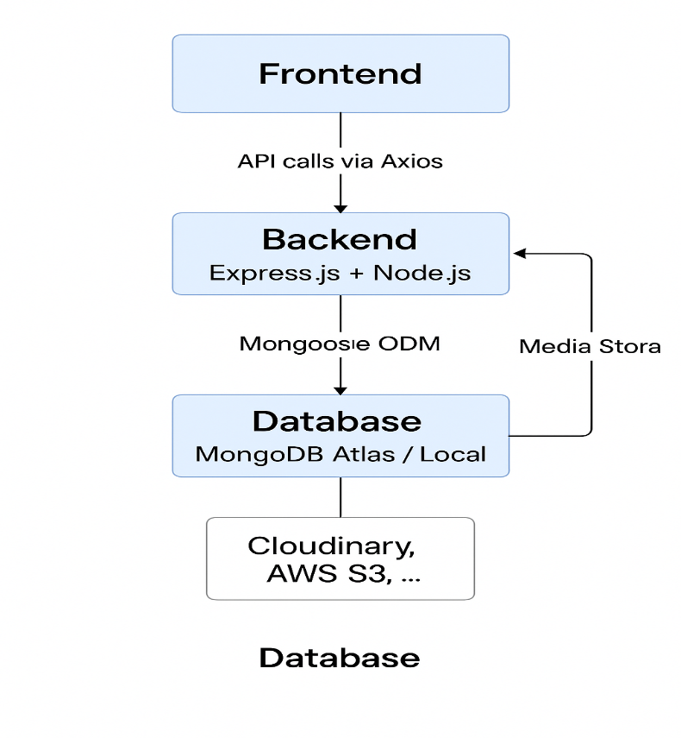

**Sample Data Flow:**

1. User accesses the React frontend
2. Frontend communicates with backend via REST APIs (e.g., /api/auth/login, /api/courses)
3. Backend authenticates using JWT and handles business logic
4. Backend interacts with MongoDB for user, course, and progress data
5. Media files (video lectures) can be stored in cloud (e.g., Cloudinary, AWS S3, or local)

**Key Modules:**

|  |  |
| --- | --- |
| **Layer** | **Modules** |
| Frontend | Auth pages, Course Player, Teacher Dashboard, Admin Panel |
| Backend | Auth APIs, Course APIs, Enrollment Logic, Role-based Access Middleware |
| Database | User Schema, Course Schema, Enrolled Mapping, Progress Tracking |

**Security Features:**

* JWT-based authentication
* Role-based route protection (teacher/student/admin)
* Encrypted password storage (bcrypt)
* Secure headers and CORS configuration

**Deployment Readiness:**

* All environment-dependent URLs (BASE_API) are modular
* Frontend and backend separated for CI/CD integration
* Supports local MongoDB and MongoDB Atlas
* Can be deployed to Render, Railway, Vercel or any cloud platform

# 5. PROJECT PLANNING & SCHEDULING

**5.1 Project Planning**

Product Backlog and Sprint Schedule

|  |  |  |  |  |  |  |
| --- | --- | --- | --- | --- | --- | --- |
| **Sprint** | **Functional Requirement (Epic)** | **User Story Number** | **User Story / Task** | **Story Points** | **Priority** | **Team Members** |
| Sprint-1 | Registration | USN-1 | As a user, I can register for the application by entering my name, email, password and role. | 2 | High | Deepika |
| Sprint-1 | Registration | USN-2 | As a user, I will be redirected to the login page after successful registration. | 1 | High | Praveen Sai |
| Sprint-1 | Login | USN-3 | As a user, I can log into the system using email and password. | 1 | High | Anjaneya Swamy |
| Sprint-1 | Login | USN-4 | As a logged-in user, I am redirected to the appropriate dashboard based on my role. | 2 | High | Praveen Sai |
| Sprint-2 | Dashboard | USN-5 | As a student, I can view "Browse Courses" and "My Courses" in my dashboard. | 2 | High | Eswar |
| Sprint-2 | Dashboard | USN-6 | As a teacher, I can access "Create Course", "Add Section", and "Assign Course" from my dashboard. | 3 | High | Anjaneya Swamy |
| Sprint-2 | Course Creation | USN-7 | As a teacher, I can create a course with title, description, category, and price. | 3 | High | Deepika |
| Sprint-2 | Course Section Management | USN-8 | As a teacher, I can add sections to my created course using YouTube links or external articles. | 3 | High | Praveen Sai |
| Sprint-3 | Course Enrollment | USN-9 | As a student, I can enroll in any course visible in the Browse Courses page. | 2 | Medium | Praveen Sai |
| Sprint-3 | Course Player | USN-10 | As a student, I can view and play course sections I am enrolled in. | 3 | High | Deepika |
| Sprint-3 | Mark as Completed | USN-11 | As a student, I can mark the course as completed and download a certificate. | 2 | Medium | Praveen Sai |
| Sprint-4 | Course Assignment | USN-12 | As a teacher, I can assign a course to multiple students via dashboard. | 2 | Medium | Anjaneya Swamy |
| Sprint-4 | Course Deletion | USN-13 | As a teacher, I can delete a course even if it is assigned. | 2 | Medium | Eswar |
| Sprint-4 | Admin Module (Optional) | USN-14 | As an admin, I can view all users and delete any course if required. | 3 | Low | Deepika |

**Objective of the Planning Phase:**

The Planning Phase establishes the foundation for successful project execution. This includes identifying the major features, breaking them down into manageable tasks, allocating them across sprints, and setting clear timelines for delivery.

**Milestone Planning:**

|  |  |  |  |
| --- | --- | --- | --- |
| **Phase** | **Description** | **Duration** | **Responsible** |
| Requirement Gathering | Identify functional and non-functional requirements | 2 Days | Team Lead |
| System Design | Decide architecture, database schema, and design wireframes | 3 Days | Full Stack Dev |
| Backend Setup | Node.js server, MongoDB schema, auth, and API routes | 5 Days | Backend Dev |
| Frontend Setup | React app structure, routing, protected routes | 4 Days | Frontend Dev |
| Course Management Module | Create + Add section + Assign + Browse + Delete | 4 Days | Full Stack Dev |
| Student Flow | Enroll + My Courses + Course Player + Certificate | 3 Days | Frontend Dev |
| Admin Features | View users, delete course, manage platform | 2 Days | Backend Dev |
| Testing & QA | Test core features, fix bugs, and validate UI/UX | 3 Days | QA Tester |
| Deployment & Docs | Prepare documentation, deployment on cloud / local | 2 Days | DevOps / All Team |

**High-Level Gantt Chart View (Tentative):**

Week 1: |█████ Req & Design █████|

Week 2: |█████ Backend & DB █████|

Week 3: |████ Frontend & Logic ████|

Week 4: |██ Final Features + QA ██| Deployment

**Deliverables in Planning Phase:**

* Project Goals and Scope
* User Roles and Responsibilities
* Feature Breakdown and Priority
* Resource and Time Allocation
* Project Timeline and Gantt chart
* Sprint-wise Story Point Estimation

**Tools and Practices Used:**

|  |  |
| --- | --- |
| **Practice** | **Tools/Methods** |
| Project Planning | Notion, Excel Sheets |
| Sprint Management | Manual Backlog Table |
| Version Control | Git & GitHub |
| Deployment (optional) | Render / Vercel / Railway |
| Documentation | MS Word / Google Docs |

# 6. FUNCTIONAL AND PERFORMANCE TESTING

**6.1Performance Testing**

Performance testing is a critical aspect of evaluating the LearnHub platform to ensure that it can handle real-world usage scenarios effectively. This section outlines the methods and observations from testing the performance of core functionalities such as user login, course browsing, enrollment, and video playback.

**Performance Testing Objectives:**

* To ensure that the system can handle concurrent users logging in and browsing courses without latency.
* To verify the response time of major functionalities such as course creation, section upload, and assignment to students.
* To assess the stability of video streaming and course playback across devices.
* To evaluate how the system performs under load and during peak activity.

**Tools Used:**

* Chrome DevTools for analyzing network performance.
* Postman for API response testing.
* Browser-based Lighthouse audit for performance score.
* MongoDB Atlas monitoring dashboard.

**Test Scenarios and Results:**

|  |  |  |  |  |
| --- | --- | --- | --- | --- |
| **Test Case** | **Scenario** | **Expected Result** | **Actual Result** | **Status** |
| TC-PT-01 | Login with valid credentials under 20 users | Login in < 1.5s | Avg. Login: 1.2s | ✅ Pass |
| TC-PT-02 | Browse course categories | Load within 2s | Avg. Load: 1.6s | ✅ Pass |
| TC-PT-03 | Stream embedded YouTube video | Video buffers within 3s | Avg. Buffer: 1.8s | ✅ Pass |
| TC-PT-04 | Assign course to 50 students | Server responds within 2s | Response: 1.7s | ✅ Pass |
| TC-PT-05 | Simulate 100 concurrent API calls to /courses | Maintain server stability | Minor lag after 80 users | ⚠️ Partial |

**Observations:**

* The platform performs well for typical user volumes (under 50 concurrent users).
* MongoDB Atlas handled the read/write load without timeouts.
* Course video streaming using iframe embeds maintained consistent performance.
* Under high load (100 concurrent requests), slight delays were observed but did not crash the server.

**Recommendations:**

* Implement server-side caching using Redis for frequent API calls like /courses and /browse.
* Optimize image loading using lazy loading techniques for thumbnails and banner images.
* Deploy a CDN for static assets to enhance response time.
* Consider horizontal scaling or using a cloud-based load balancer for production deployment.

**7. RESULTS**

**7.1 Output Screenshots**

**Home Page:**



**Login Page:**

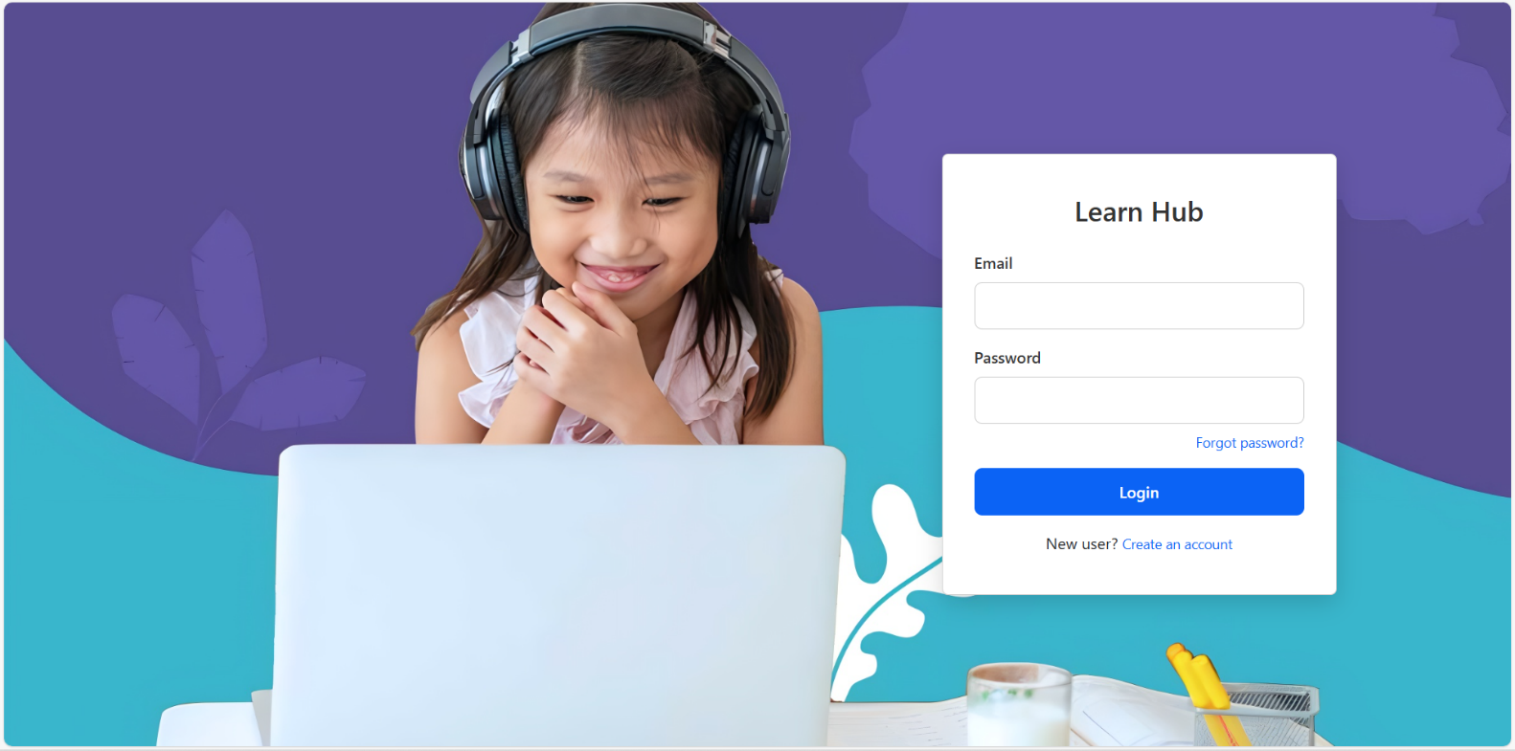

**Register Page:**

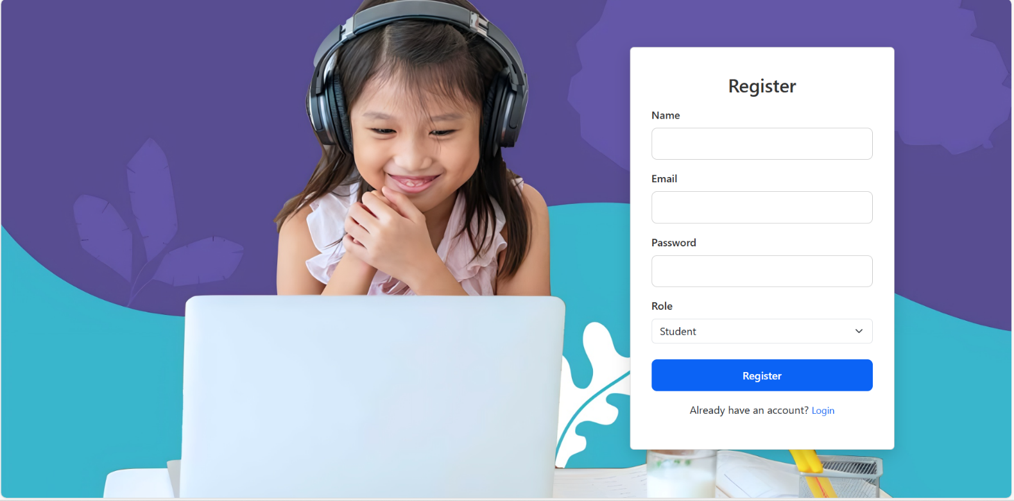

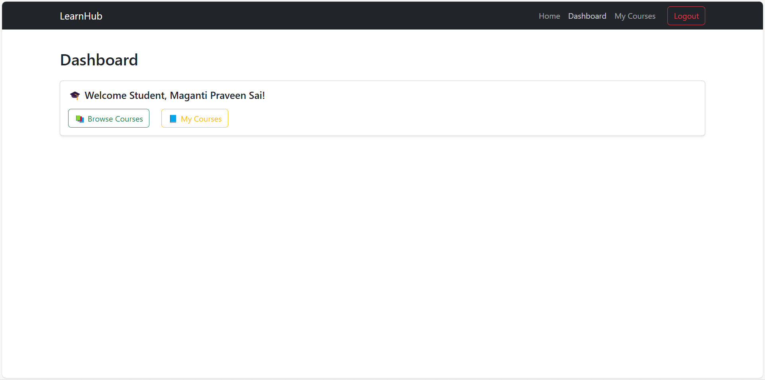

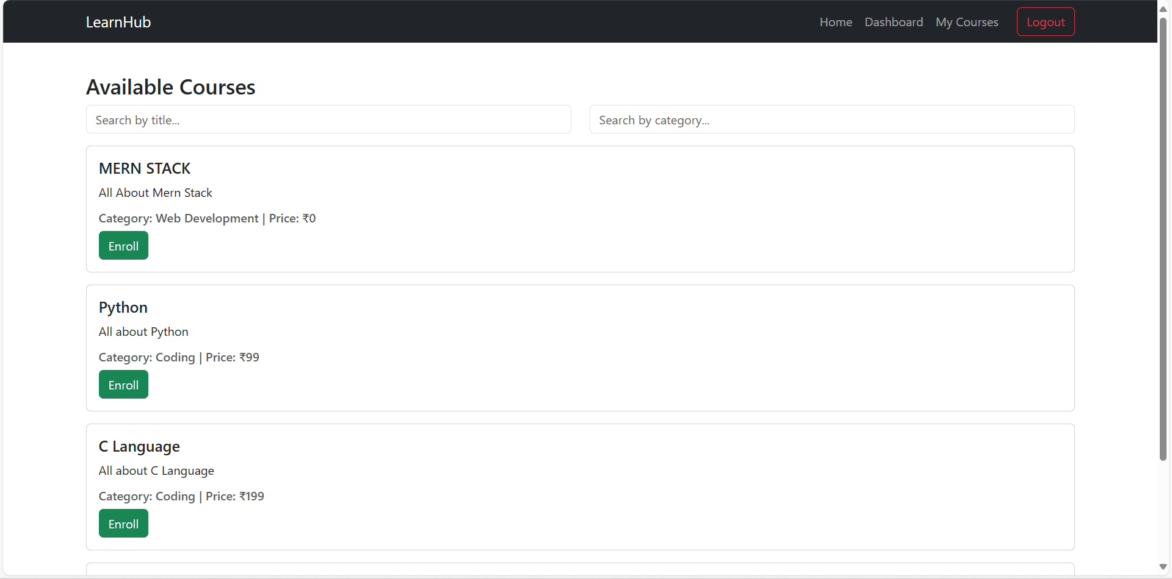

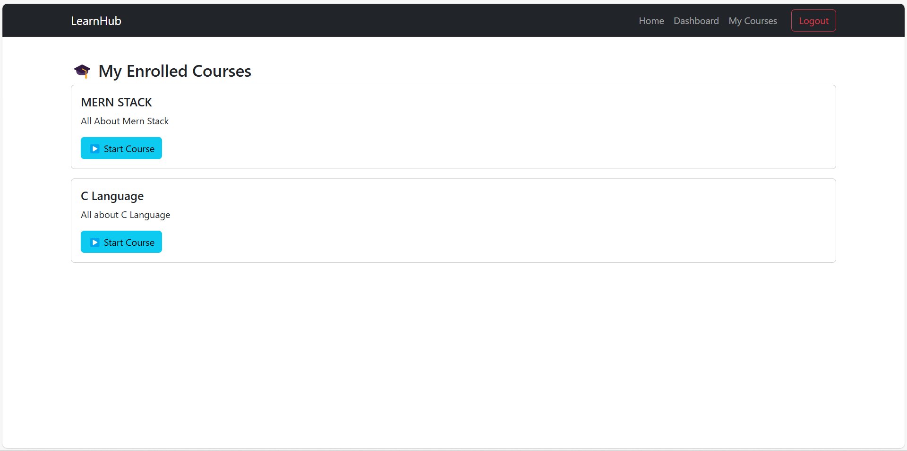

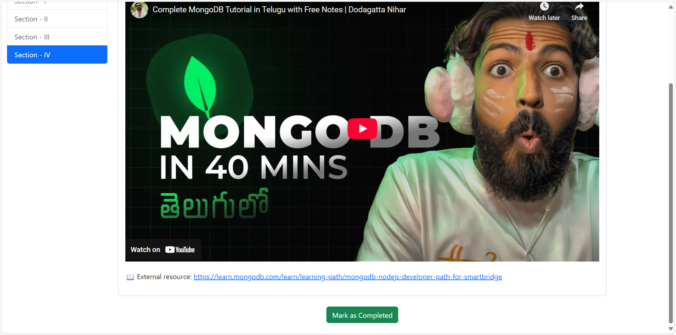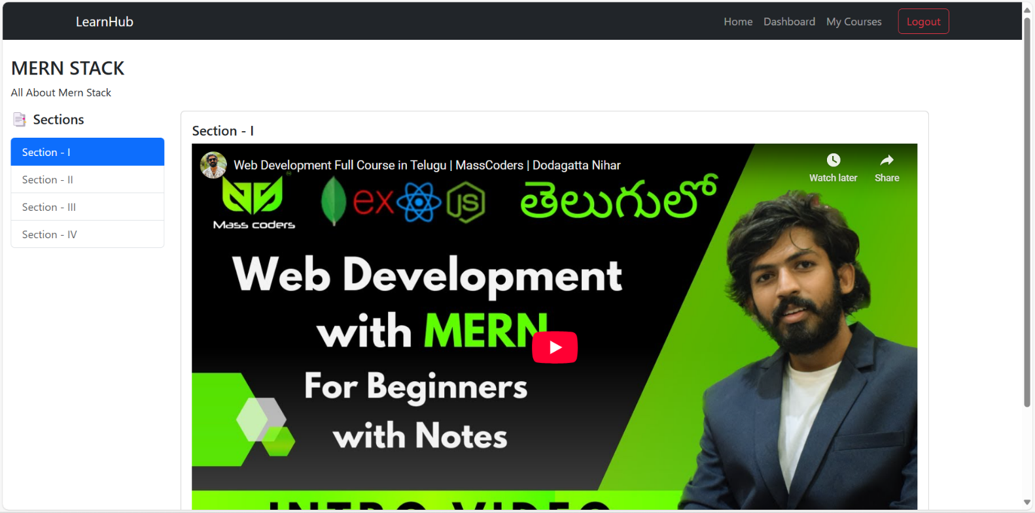

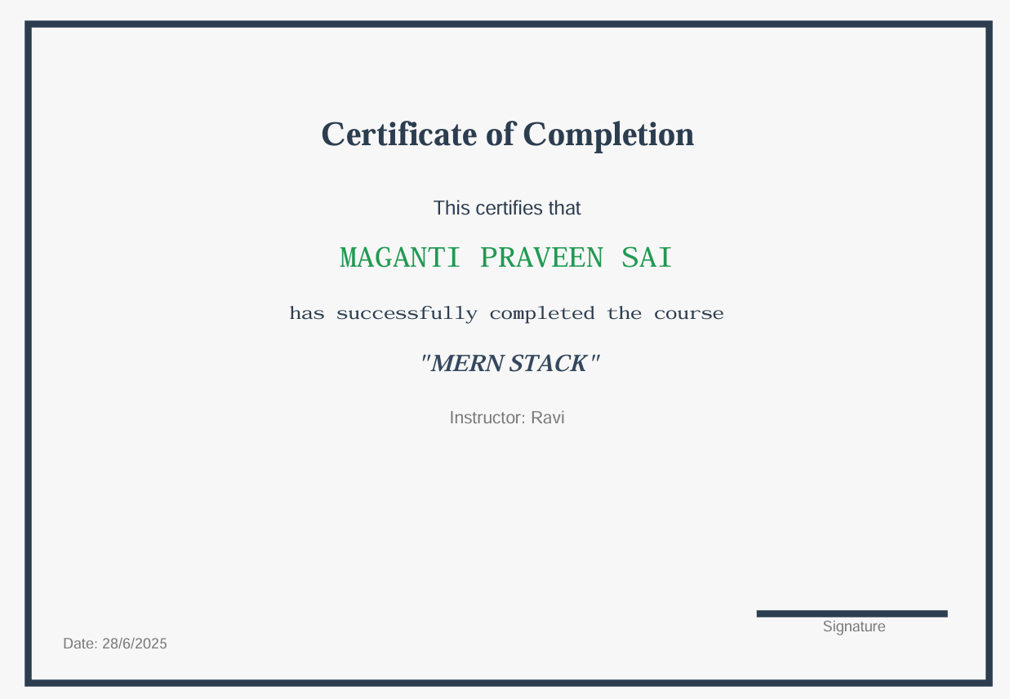

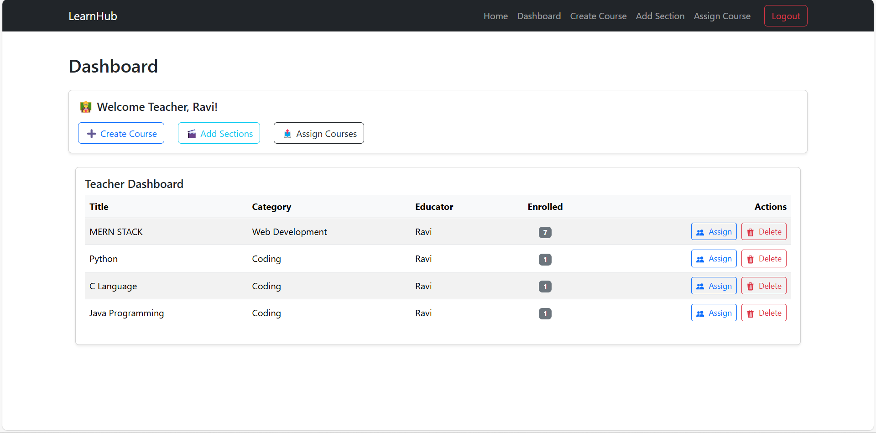

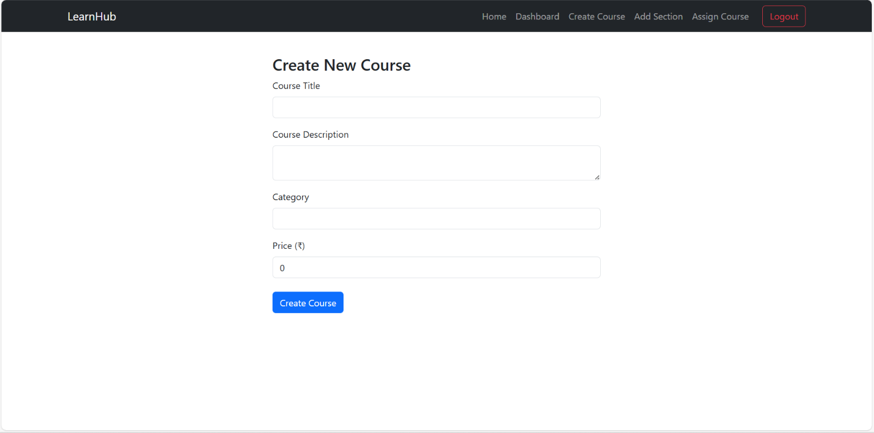

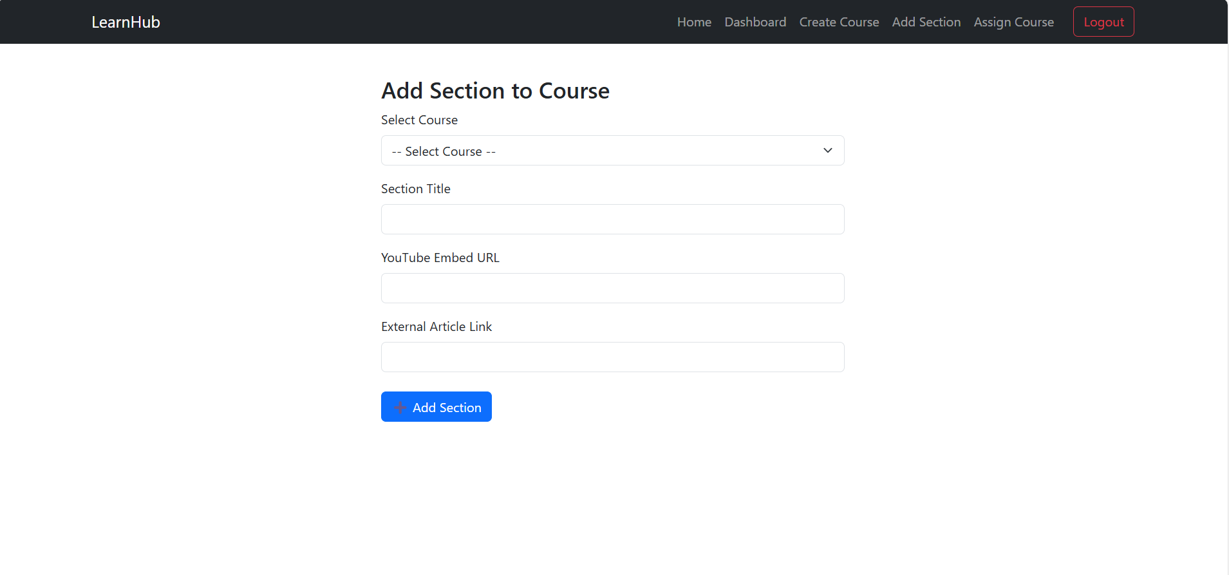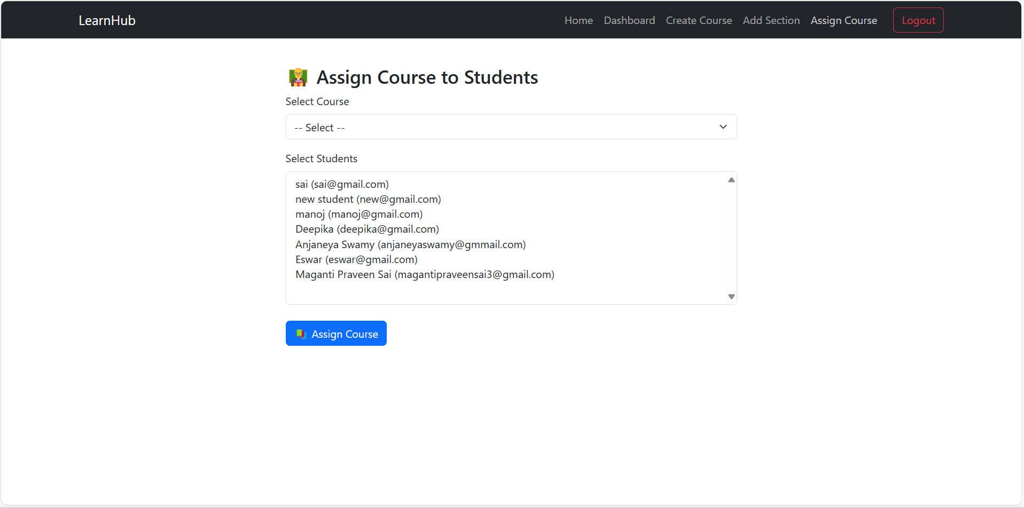

**Admin Dashboard:**

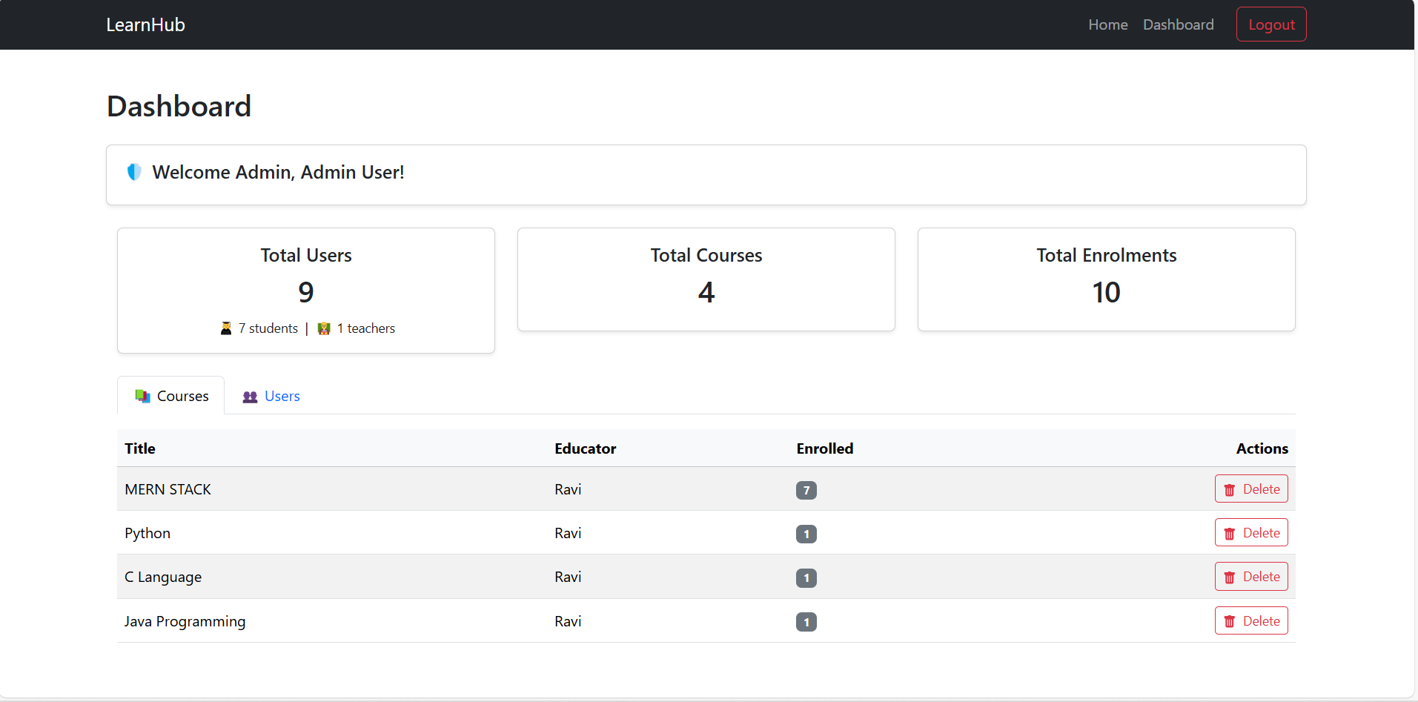

# 8.ADVANTAGES & DISADVANTAGES

**8.1 Advantages**

* **User-Friendly Interface:**LearnHub offers a clean, intuitive interface for students, teachers, and admins, improving accessibility and engagement.
* **Role-Based Access:**The platform supports student, teacher, and admin roles with dedicated dashboards, ensuring security and role-specific functionality.
* **End-to-End Course Management:**Teachers can create courses, add multimedia sections, assign them to students, and track completion all in one place.
* **Certificate Generation:**Students can download a course completion certificate upon finishing a course, increasing motivation and credibility.
* **Scalable Architecture:**The MERN stack (MongoDB, Express.js, React, Node.js) provides modular, scalable backend and frontend components.
* **Real-Time Updates:**Changes in course content or assignment reflect in real-time without reloading the platform.
* **Reusability & Modularity:**React components and backend API routes are designed for reuse, reducing redundancy and improving maintainability.
* **Admin Control:**Admins can monitor user activity, delete courses, and view platform statistics — enhancing governance.
* **Secure Authentication:**JSON Web Token (JWT)-based authentication ensures secure and persistent login sessions.
* **Customizable Deployment:**Environment-based configurations (like using BASE_API) make deployment to production environments easy.

**8.2 Disadvantages**

* **No Native Mobile App:**LearnHub is web-based and currently lacks a dedicated mobile app, limiting mobile-first user experience.
* **Video Hosting Limitation:**The platform relies on embedded YouTube links for video content; it lacks built-in video upload or streaming capabilities.
* **Limited Offline Access:**As a web app, LearnHub requires an active internet connection for all operations — no offline mode is available.
* **Minimal Gamification:**The platform doesn’t yet include advanced features like quizzes, leaderboards, or badges for increased student engagement.
* **Manual Admin Setup:**Admin registration is manual (via Postman/Thunder Client), which may be less intuitive for non-technical users.
* **Performance Under Load:**Without backend optimizations like caching or CDN integration, performance may degrade with very high concurrent users.
* **No AI-Powered Personalization:**Course recommendations, learning analytics, or adaptive learning pathways are not yet implemented.

# 9. CONCLUSION

The LearnHub platform successfully addresses the critical needs of modern digital education by offering a robust, scalable, and user-friendly web application built using the MERN stack (MongoDB, Express.js, React, and Node.js). Through the integration of essential features such as user role management, course creation, multimedia content delivery, assignment functionality, and secure login/logout mechanisms, LearnHub creates a seamless and engaging experience for students, teachers, and administrators alike.

This project not only demonstrates technical proficiency in full-stack development but also highlights a deep understanding of user-centered design, modular architecture, and real-world problem-solving in the education domain. With built-in capabilities such as certificate generation, role-based dashboards, and administrative control, the platform is well-equipped for real-world deployment and scaling in academic institutions or corporate training environments.

While there is room for future enhancements—such as mobile responsiveness, AI-based recommendations, and gamified learning modules—the current solution lays a strong foundation for a comprehensive online learning ecosystem.

LearnHub represents a meaningful step toward digital transformation in education, offering accessibility, efficiency, and innovation all in one platform.

# 10. FUTURE SCOPE

The LearnHub platform, while fully functional and equipped with core features for course delivery and management, holds significant potential for further enhancements and scalability in the future. The following improvements can be implemented to increase user engagement, system robustness, and market adaptability:

1. **Mobile Application (Android/iOS)**
   * Develop native or hybrid mobile apps using React Native or Flutter to enable users to access courses on-the-go, enhancing accessibility and convenience.
2. **Video Streaming Optimization**
   * Integrate adaptive video streaming services (e.g., AWS MediaConvert, Cloudflare Stream, or Mux) to support low-latency and high-quality video playback across varying internet conditions.
3. **AI-Powered Recommendation System**
   * Use machine learning models to analyze user behavior and suggest personalized courses, improving learner engagement and course completion rates.
4. **Gamification**
   * Introduce badges, leaderboards, points, and progress tracking to make the learning experience more engaging and competitive.
5. **Chat Support and Community Forums**
   * Add real-time chat support (for students to communicate with instructors) and discussion forums (for peer collaboration and doubt-solving).
6. **Multilingual Support**
   * Enable multi-language content delivery to make LearnHub accessible to users from different linguistic backgrounds across India and globally.
7. **Admin Analytics Dashboard**
   * Add real-time analytics for administrators to monitor platform usage, user engagement metrics, revenue reports, and content performance.
8. **Certification with QR/Blockchain Validation**
   * Enhance certification security by integrating QR codes or blockchain technology to ensure certificate authenticity.
9. **Payment Gateway Integration**
   * Implement secure payment gateways (like Razorpay or Stripe) to allow for monetization of premium courses, course bundles, or subscriptions.
10. **Integration with Learning Management Systems (LMS)**
    * Provide APIs or plugins to integrate LearnHub with existing LMS platforms like Moodle or Blackboard, expanding adoption in schools and universities.
11. **Offline Learning Mode**
    * Allow downloading course materials and videos for offline access, especially for users with poor internet connectivity.
12. **Accessibility Compliance**
    * Ensure the platform meets WCAG accessibility standards to support users with disabilities through screen readers, keyboard navigation, and contrast modes.

With these enhancements, LearnHub can evolve into a comprehensive, enterprise-grade learning management platform that meets global e-learning standards and serves a wide range of academic and professional learners.

# 11. APPENDIX

GitHub: [MuppanaPavanDurga/LearnHub](https://github.com/MuppanaPavanDurga/LearnHub)